**MODIFY HEADERS CHROME EXTENSION**

THIS EXTENSION IS USED TO TEST AUTHORIZATION TOKEN TO UPDATE OR DELETE INFORMATION IN OUR API

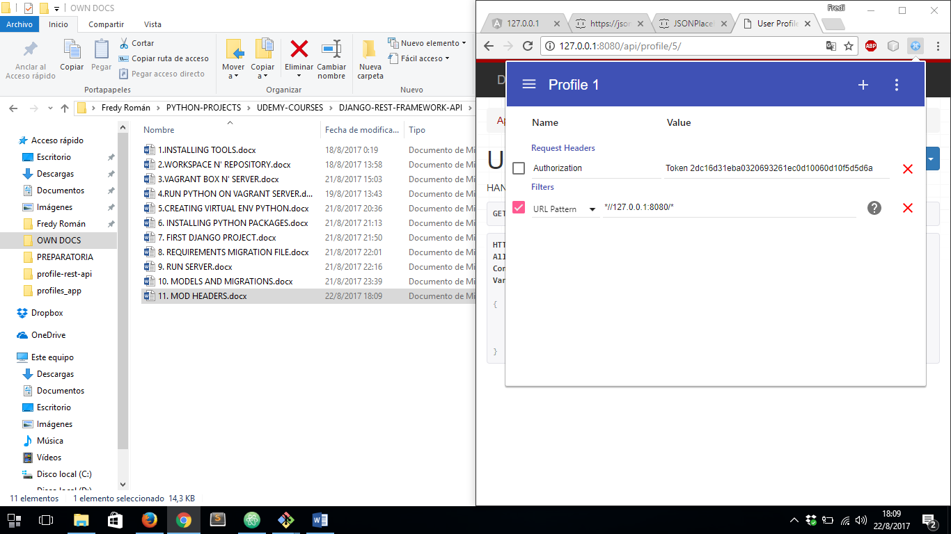

IF AUTHORIZATION FIELD IS NOT CHECKED, OUR API DOES NOT ALLOW A USER TO UPDATE OR DELETE INFORMATION.